A
Project Report
On
REAL TIME CHAT APPLICATION
Submitted for the partial fulfillment of the requirement for the award of theDegree of
BACHELOR OF TECHNOLOGY
(Computer Science & Engineering)
By:
SHIVAM -- 2100700100032
ISHA RANI -- 2100700100016
UNDER THE GUIDANCE OF
MR. VARUN KAUSHIK SIR (H.O.D. CSE)
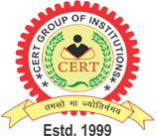
SUBMITTED TO :

COLLEGE OF ENGINEERING & RURAL TECHNOLOGY, MEERUT
(Approved by A.I.C.T.E.)
Affiliated to
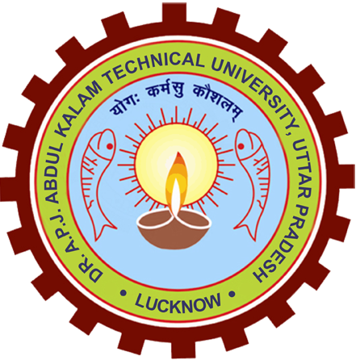

Dr. A.P.J. ABDUL KALAM TECHNICHAL UNIVERSITY, LOCKNOW
(Batch : 2021- 2025)

